

Practices for Secure Software Report

Table of Contents
Document Revision History 3
Client 3
Instructions 3
Developer 4
1. Algorithm Cipher 4
2. Certificate Generation 4
3. Deploy Cipher 4
4. Secure Communications 4
5. Secondary Testing 4
6. Functional Testing 4
7. Summary 4
8. Industry Standard Best Practices 4

Document Revision History

Version | Date | Author | Comments
1.0 | 12/08/2025 | Dakota Osborne

Client



Instructions

Submit this completed practices for secure software report. Replace the bracketed text with the relevant information. You must document your process for writing secure communications and refactoring code that complies with software security testing protocols.

- Respond to the steps outlined below and include your findings.
- Respond using your own words. You may also choose to include images or supporting materials. If you include them, make certain to insert them in all the relevant locations in the document.
- Refer to the Project Two Guidelines and Rubric for more detailed instructions about each section of the template.

Developer
Dakota Osborne

Algorithm Cipher

The encryption algorithm take in a message or some sort of data and pass it into the encryption algorithm to convert it into a new form that if an attacker obtains, they can not make sense of it. There are 2 types of cipher algorithms, one type that allows the data that is converted to be converted back to is original form with a key and the other type the cannot be converted back. The cipher algorithms that can not be converted back to its original form is the most robust cipher algorithms there are. The hash function is an example of a cipher algorithm that does not allow for the data to convert the data back to its original form. I used the SHA2-512 algorithm for this project because of its high bit level. The higher the bit level is the more secure the algorithm is. The hash function creates larger hashes of the data which increases difficulty for any algorithm or computer to decode the cipher and determine what the original value was.
For encryption algorithms that use keys to convert the encrypted data back into its original from, there are symmetrical and non-symmetrical keys that can be used. Symmetrical key encryption algorithms use one private key. This key is shared with anyone and should be kept secure, it is used to unencrypt data. Non-symmetric key encryption algorithms use a public and private key to encrypt and decrypt data. The public key is shared with anyone and does not necessarily need to be kept secure. The public key is used to encrypt the data. The private key is used the decrypt the data and should be kept private. The non-symmetric key encryption algorithms are less secure than symmetrical key algorithms so they usually generate larger random numbers to make it computationally impossible to determine the original form of the data from the encrypted data. Both versions use large random numbers that satisfy several different attributes that make it a strong for encryption. An example of an attribute is for the RSA algorithm that uses public and private keys, is the large random numbers must be prime.
The first encryption algorithms used many years ago started out by shifting the letter that is used. For example shifting the letter A 13 characters would convert it to M. Doing this for every letter in a message would create a message that was difficult but not impossible to decrypt without the original cipher number. The current state of encryption involves creating very large random numbers that transform the data into an encrypted form. The theory behind these newer encryption algorithms is that it is computationally impossible with todays computers and algorithms to decrypt encrypted data without a key. There has been breakthroughs with quantum computers that could allow those with access to such computers to decode the best encryption algorithms, so the encryption algorithms used today may be ineffective in the near future.

Certificate Generation
Insert a screenshot below of the CER file.

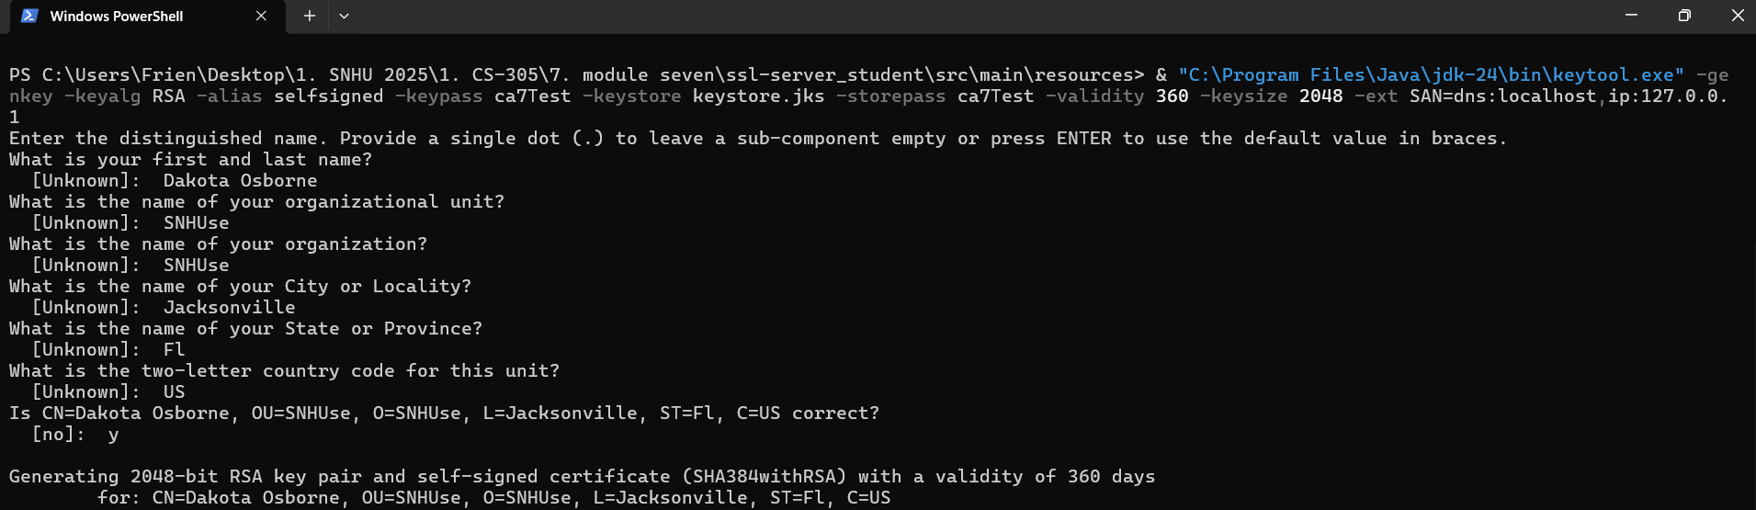
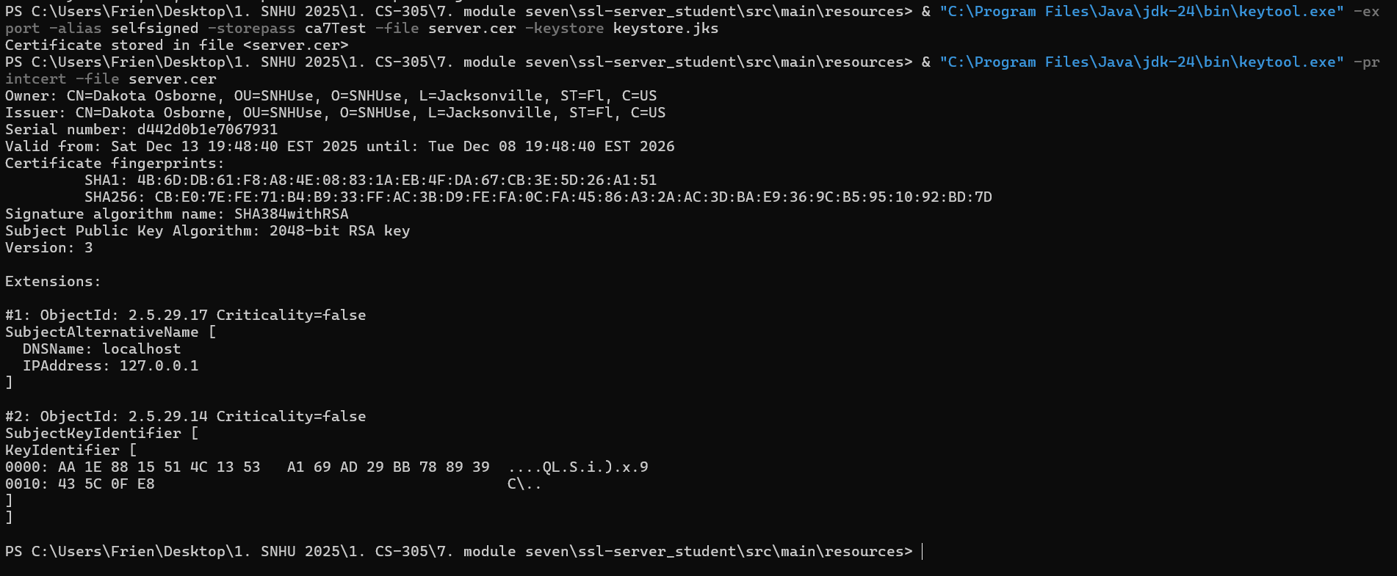

Deploy Cipher
Insert a screenshot below of the checksum verification.

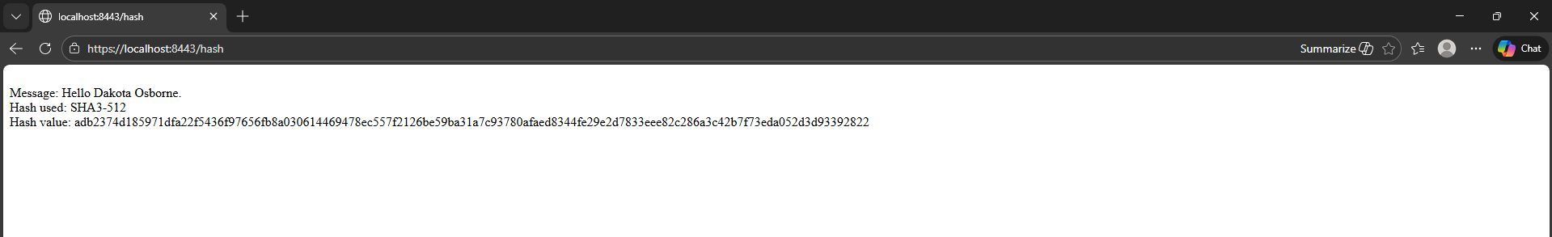

Secure Communications
Insert a screenshot below of the web browser that shows a secure webpage.



Secondary Testing
Insert screenshots below of the refactored code executed without errors and the dependency-check report.
Pre refactor Dependency check:
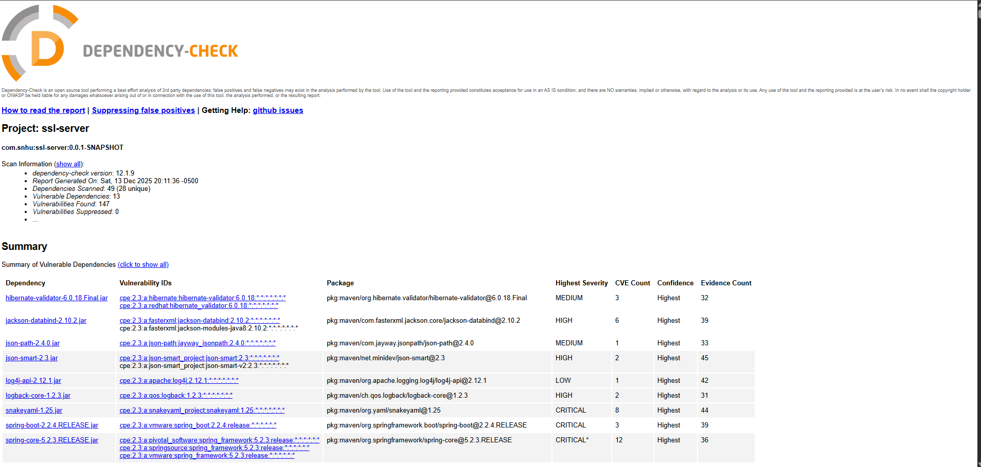
Post refactor Dependency check:
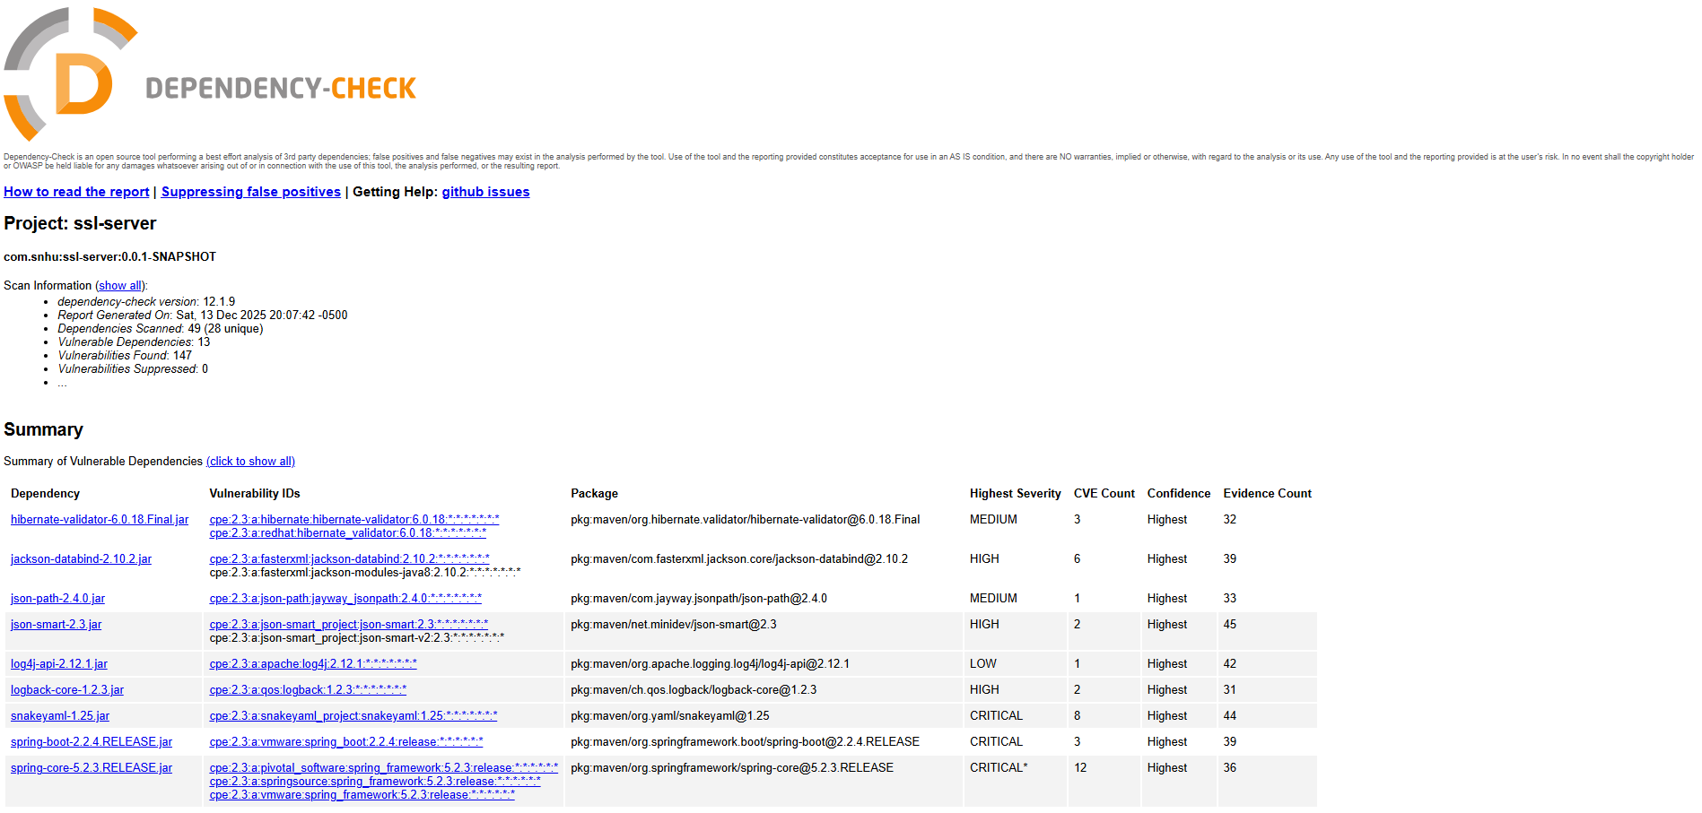

Functional Testing
Insert a screenshot below of the refactored code executed without errors.

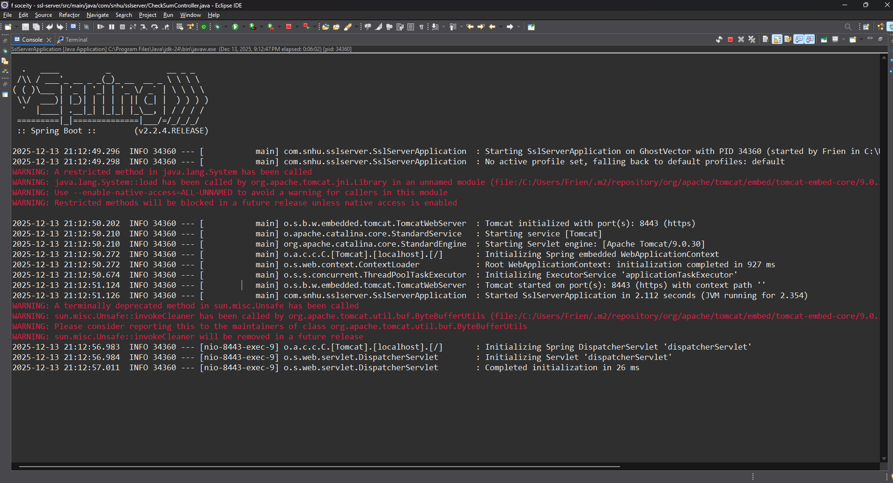

Summary

When I refactored the code I had to add several attributes to make the connection to the server secure (using https). It already had the ssl protocol implemented within the code. To use this protocol there were several steps I needed to accomplish for the program to run without any errors. First I create a secure socket with the SocketFactory class using the previously established port. I then created a certification in the projects directory. I updated the program’s application properties to tell the ssl protocol to use the correct key store in the directory. I found that because I created the certificate by self signing it and it was not created by a trusted CA the browser did not trust the certificate and the https protocol was not used and the website was not secure. To fix this I installed the certificate onto my OS trusted CA store by exporting the certificate, and following the install instructions within the certificate file.
I implemented a check sum hash by creating a RESTful mapping to /hash using the @RESTcontroller and @Getmapping(“/hash”) attributes in the CheckSum program. Within this method I created a MessageDigest object using the SHA3-512 hash algorithm and digested the message I hard coded into the method. I then returned the hash and original message for it to show on the webpage.

Industry Standard Best Practices

I implemented several things within the application for the website to use the https protocol so that the traffic between client and server is secure. I used Message Digest with a strong SHA3-512 hash function for a checksum. I used the SocketFactory to establish a secure socket for secure information to travel to that port. I used created a certificate to create trust between the client and the server.
It is very important to use industry best practices for security purposes because these best practices have been researched extensively to ensure that if implemented correctly there are no vulnerabilities for attackers to exploit. With no way to exploit the companies server, they will be able to continuously provide their service to their customers and not have to end up paying large sums of money due to data breaches.

